NAND2TETRIS ASSIGNMENT N
Name : Sukhvinder Kaur
[A] HalfAdder
Schematic diagram :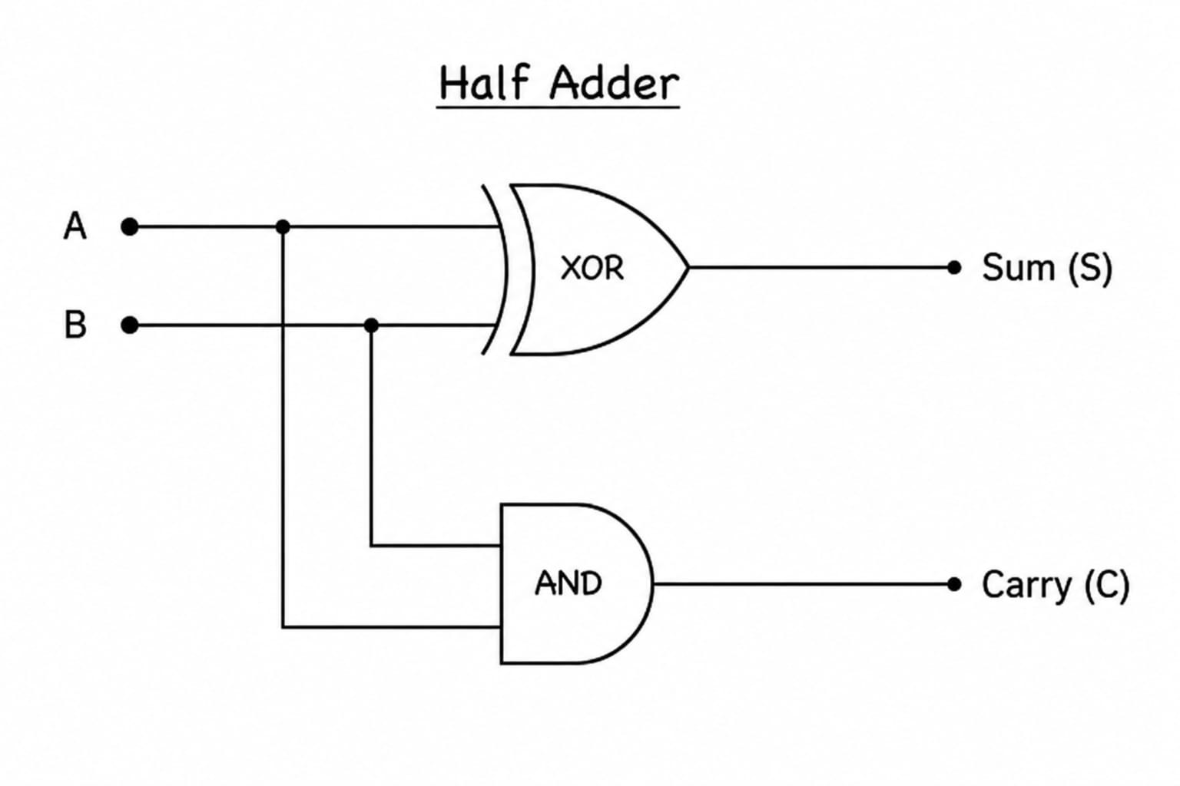
Boolean Expression & Truth Table :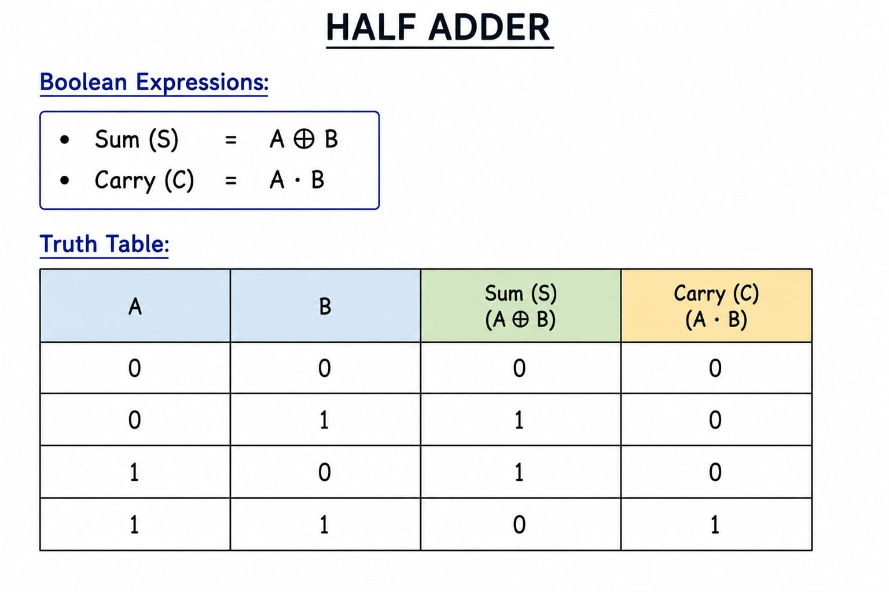
Code :
CHIP HalfAdder {
IN a, b;
OUT sum,
carry;

PARTS:
Xor(a=a, b=b, out=sum );
And(a=a, b=b, out=carry );

}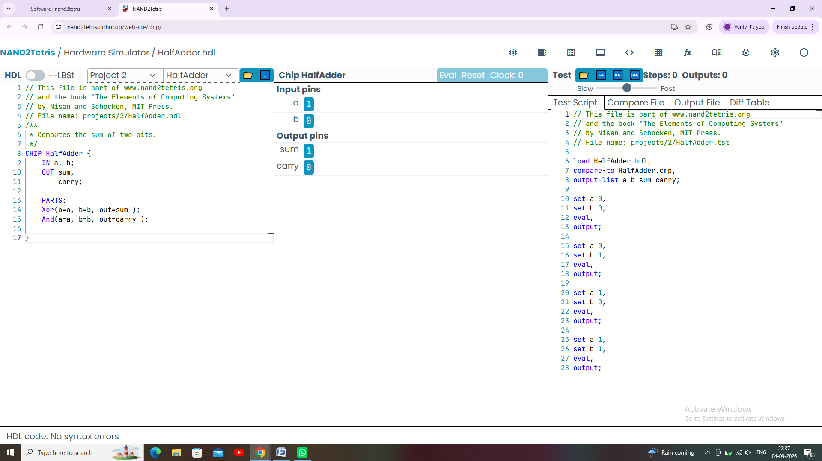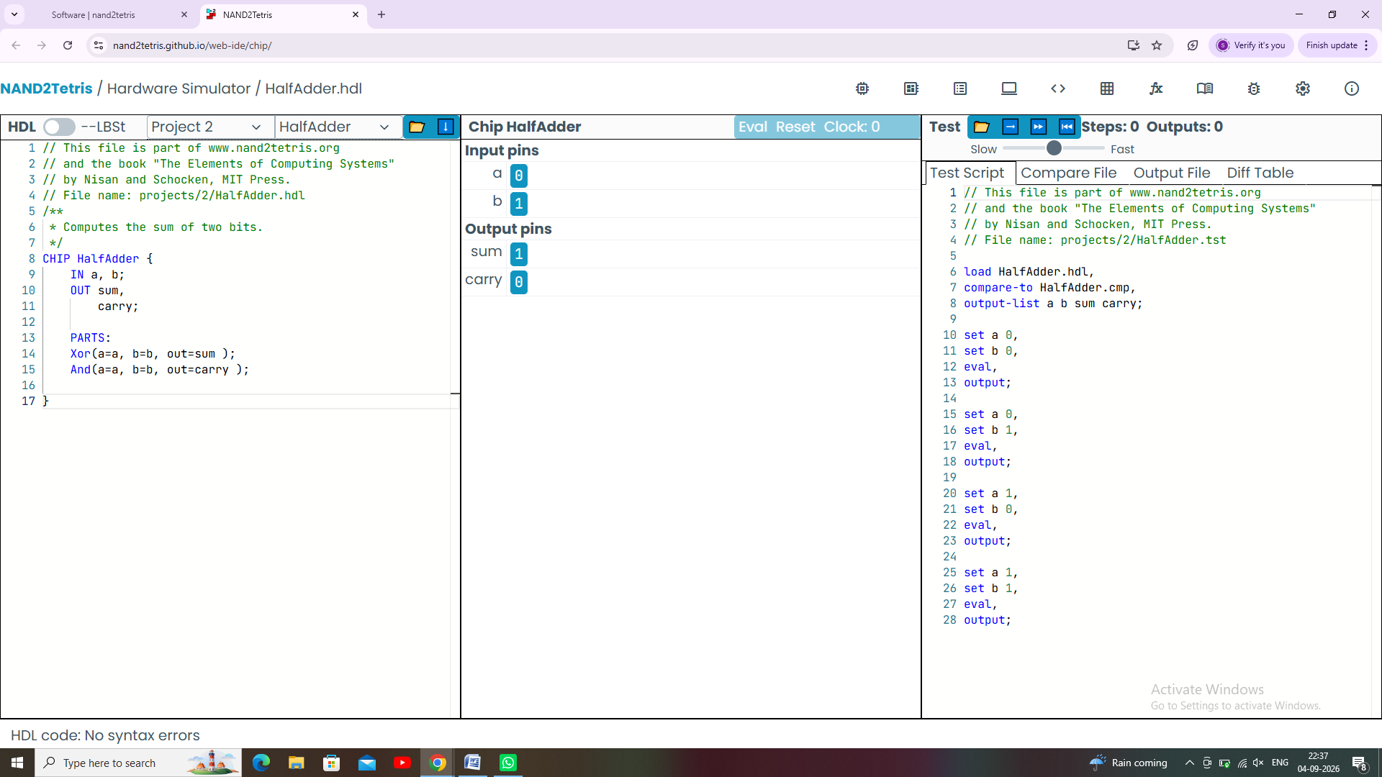
[B] FullAdder
Schematic Diagram :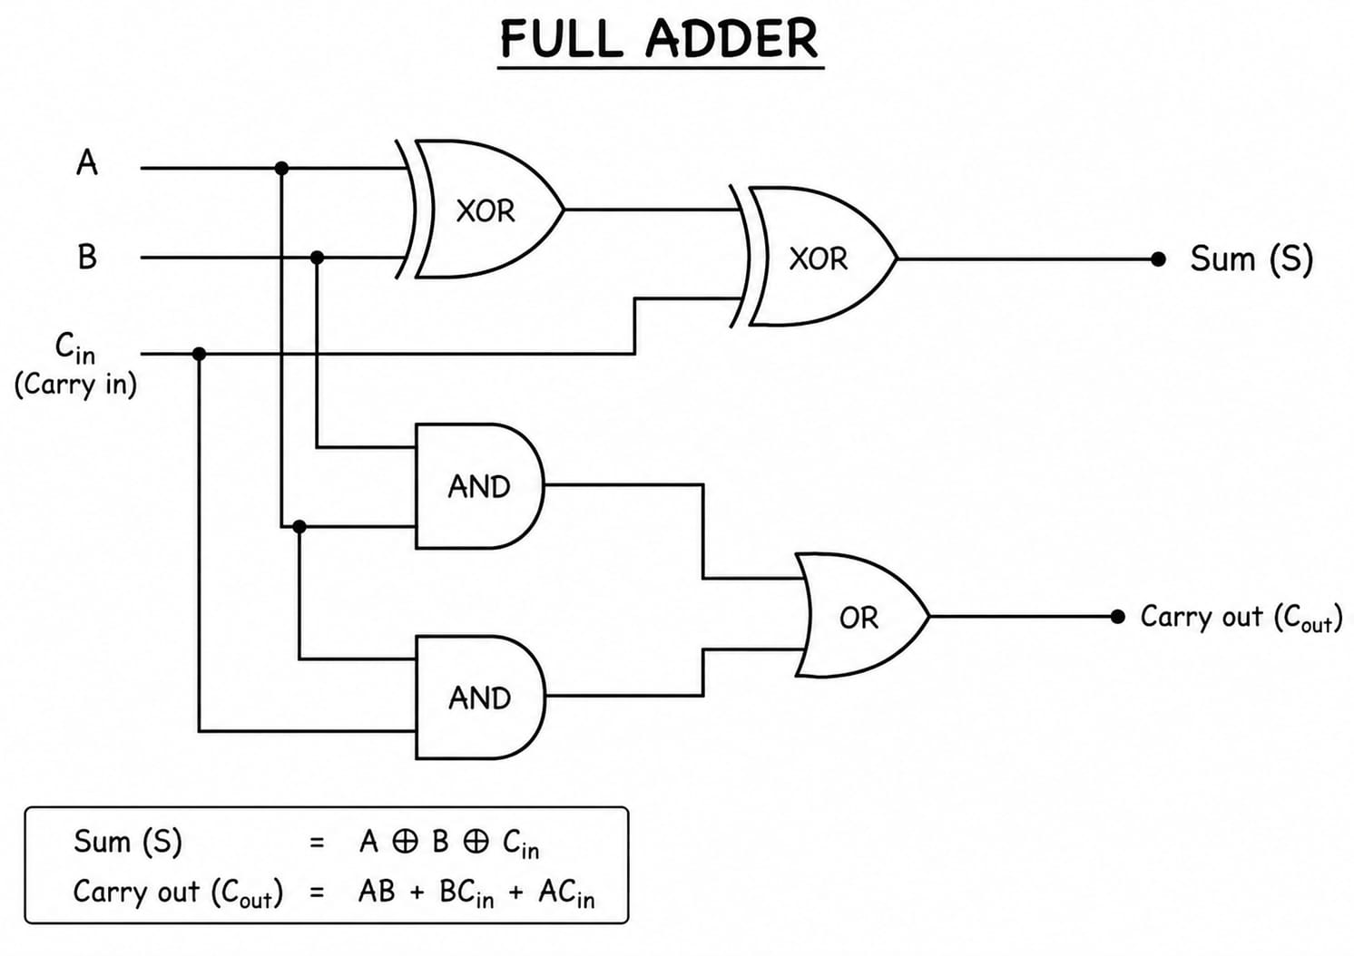
Boolean Expression & Truth Table :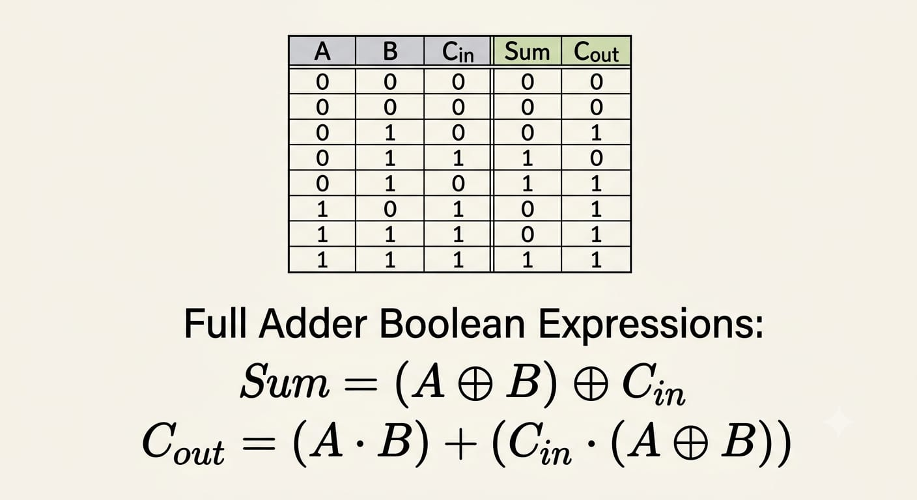
Code :
CHIP FullAdder {
IN a, b, c; // 1-bit inputs
OUT sum, // Right bit of a + b + c
carry; // Left bit of a + b + c

PARTS:
Xor(a=a, b=b, out=ab);
Xor(a=ab, b=c, out=sum);
And(a=a, b=b, out=c1);
And(a=a, b=c, out=c2);
And(a=b, b=c, out=c3);
Or(a=c1, b=c2, out=c12);
Or(a=c12, b=c3, out=carry);
}